Project Design Phase-II
Technology Stack (Architecture & Stack)

Date | 12 January 2026
Team ID | SWTID-2026-7310
Project Name | Auto Ticket Classification using Flow Designer
Maximum Marks | 4 Marks

Technical Architecture:
The Deliverable shall include the architectural diagram as below and the information as per the table1 & table 2
Architecture of Auto Ticket Classification using Flow Designer (ServiceNow):
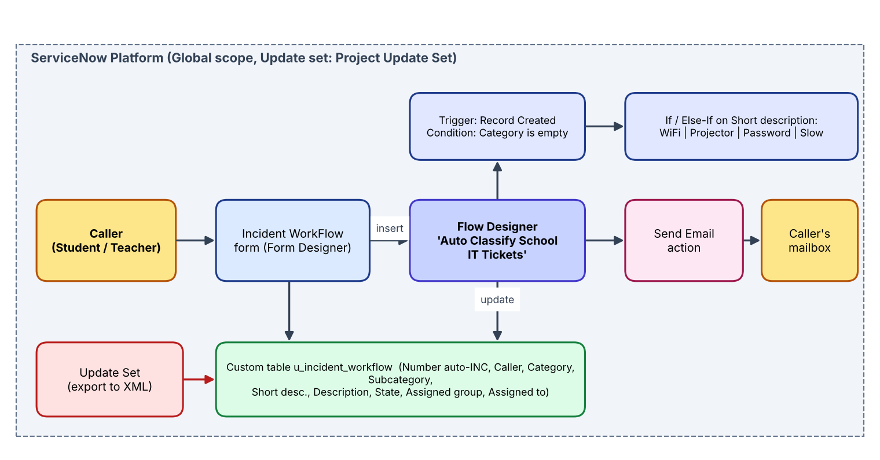

Table-1 : Components & Technologies:
S.No | Component | Description | Technology
 | User Interface | ServiceNow form (Incident WorkFlow) used by callers and agents | ServiceNow Next Experience UI / Form Designer
 | Application Logic-1 | Auto classification: trigger on record created, If / Else-If on Short description | ServiceNow Flow Designer (no-code)
 | Application Logic-2 | Update Record action sets Category and Subcategory | Flow Designer action - Update Record
 | Application Logic-3 | Send Email action to the caller after classification | Flow Designer action - Send Email (SMTP)
 | Database | Custom table u_incident_workflow with auto-number INC, choice and reference fields | ServiceNow platform database
 | Cloud Database | Database hosted by the ServiceNow instance | ServiceNow cloud (Personal Developer Instance)
 | File Storage | Update set exported as XML (sys_remote_update_set_*.xml) | Local file system / Mail / WhatsApp
 | External API-1 | Not used | -
 | External API-2 | Not used | -
 | Machine Learning Model | Not used - rule based keyword matching | -
 | Infrastructure (Server / Cloud) | Application deployment on cloud  Local Server Configuration: not required  Cloud Server Configuration: ServiceNow instance, Global application scope | ServiceNow cloud

Table-2: Application Characteristics:
S.No | Characteristics | Description | Technology
 | Open-Source Frameworks | No-code low-code platform; no open-source frameworks needed | ServiceNow Flow Designer
 | Security Implementations | Access control (ACL) on the custom table via role u_incident_workflow_user; only authorised users modify tickets | ServiceNow ACLs / roles
 | Scalable Architecture | New categories or keywords added as configuration; platform scales with ticket volume | Flow Designer + choice lists
 | Availability | Hosted on ServiceNow cloud with platform-level availability | ServiceNow cloud platform
 | Performance | Flow runs on record creation within seconds; simple contains-conditions with no external calls | Flow Designer (synchronous record trigger)

References:
https://c4model.com/
https://developer.ibm.com/patterns/online-order-processing-system-during-pandemic/
https://www.ibm.com/cloud/architecture
https://aws.amazon.com/architecture
https://medium.com/the-internal-startup/how-to-draw-useful-technical-architecture-diagrams-2d20c9fda90d

